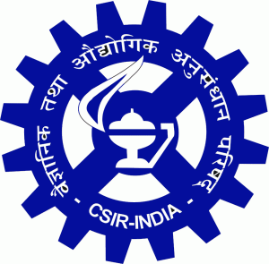 | National Council of Science & Technology Communication  Department of Science & Technology,  Govt. of India  In association with VDS Jaipur  & CSIR-Central Electronics Engineering Research Institute, Jaipur Centre  Science Media Research:  Science Creatives & Media School for Scientists & Media  6 to 8 Marh. 2019 | 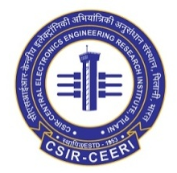

Venue: CSIR-CEERI's Incubation-cum-Innovation Hub, Jaipur Centre,
CFC-1, Malviya Industrial Area, Jaipur-302017

Registration Form
Name of Delegate/Participant :
Designation :
Qualification :
DOB :
Addressof Delegate/Participant :
(District/State/Pin code): Email-ID: Contact Number :
Organization Details
Name of the organization :
Address of the Organization :
Contact number (guide/employer):
Email Id (guide/employer) :
Your interest to participate in the workshop:

Signature of the applicant with date
Submit filled form latest by 3rd March, 2019 at
iijaipur@ceeri.res.in & gsmeena82@gmail.com

